1. **Introduction**

The overall approach of the project testing can be separated into three parts: basic GUI functions, accuracy performance calculation and message checking. These parts have been finished during the three testing demonstration from week 8 to week 10.

For the first part, the test target is to getting all the buttons, labels, text area function successfully. In order to decide the first testing phase is completed, all the labels, text area and buttons must be show in the user interface and can achieved their functionalities, such as the buttons should be go to different page or pop out a dialog window.

For the second part, the test target is to getting the accuracy performance calculation function successfully. In order to decide the second testing phase is completed, the Facebook data should be extracted and input into the system, the machine learning algorithm models should be built up with the data, calculate their accuracies successfully and plot out a bar chart.

For the last part, the test target is to getting the message checking function successfully. In order to decide the last testing phase is completed, the user should be able to enter the message in the text area, the algorithm should be able to tokenize the input message and compare all the token with the suicide related keywords, and check button functions with pop out different result dialog windows.

1. **Test Report**
   1. Unit Testing

Unit Test 1: A testing for running the GUI

Input: the GUI coding

Expected output: return a user interface if a GUI run out successfully or return nothing or error if a GUI fail to run out.

The test output: user interface

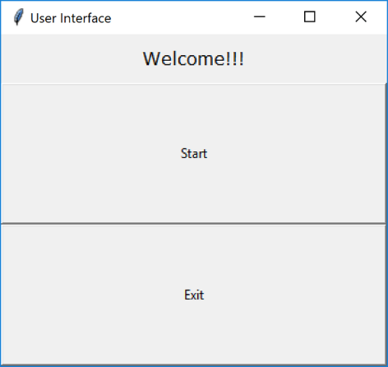

Unit Test 2: A testing for building up the machine learning algorithm models

Input: a sample Facebook message dataset

Expected output: return a successful message if models build out successfully or return a failure message if models fail to build out.

The test output: message “successful” returned

Unit Test 3: A testing for accuracy calculation

Input: machine learning algorithm models and a sample Facebook message training and testing dataset

Expected output: return a successful message if accuracy calculation successfully or return a failure message if accuracy calculation fail.

The test output: message “successful” returned.

Unit Test 4: A testing for graph plotting

Input: accuracy calculation of each models

Expected output: return a bar chart if graph potting successfully or return error if the graph potting fail.

The test output: a bar chart returned.

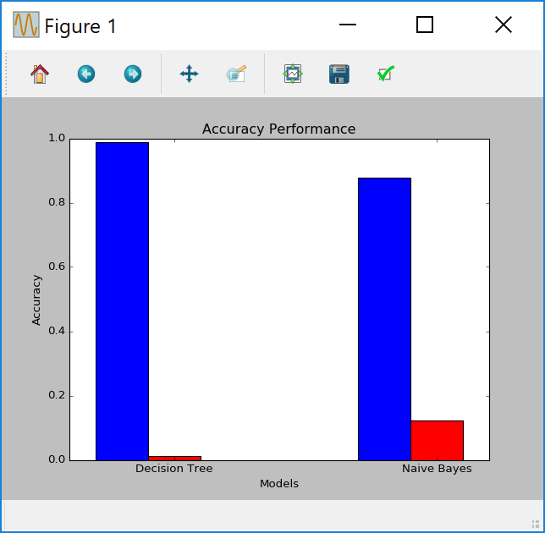

Unit Test 5: A testing for user input in the message area

Input: user message, action of clicking the button

Expected output: return a congratulation dialog window or warning dialog window if user entered a message (either with or without suicide related keywords are fine) or return error dialog window if user entered nothing.

The test output: a congratulation dialog window or warning dialog window returned.

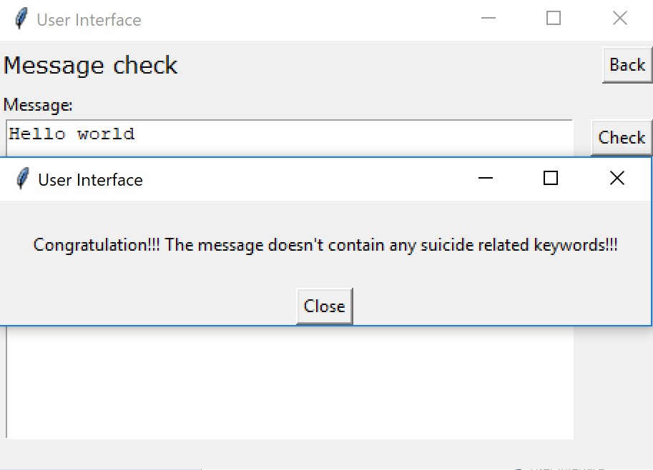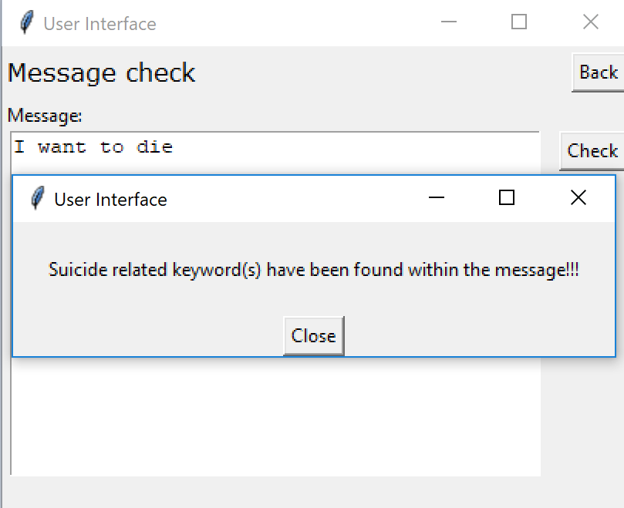

Unit Test 6: A testing for user input in the message area

Input: empty user message, action of clicking the button

Expected output: return a congratulation dialog window or warning dialog window if user entered a message (either with or without suicide related keywords are fine) or return error dialog window if user entered nothing.

The test output: an error dialog window returned.

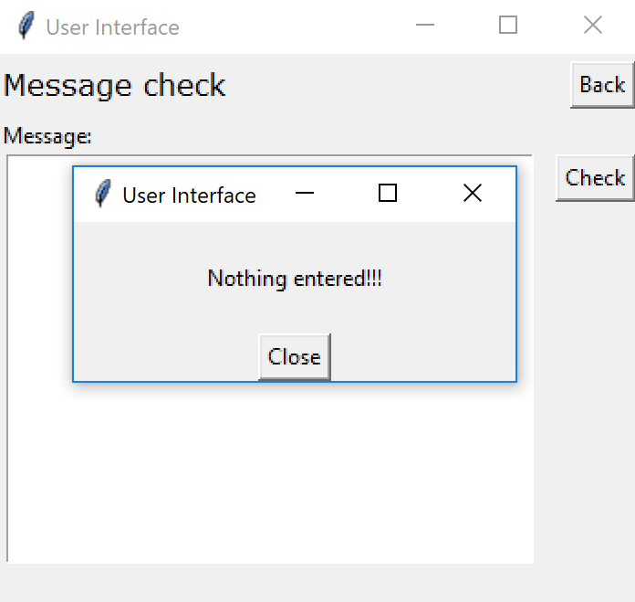

Unit Test 7: A testing for tokenize the message input

Input: user message

Expected output: return successful message if tokenize the message input successfully or return a failure message if tokenize the message input fail.

The test output: message “successful” returned.

* 1. System Testing

Integration Test 1: A testing for the overall function of option one – Accuracy Performance

Expected output: return a successful message if it successfully finished all the functionalities of option 1 or return a failure message if it fails during the processes of option 1.

The test output: message “successful” returned.

Integration Test 2: A testing for the overall function of option two – Message check

Expected output: return a successful message if it successfully finished all the functionalities of option 2 or return a failure message if it fails during the processes of option 2.

The test output: message “successful” returned.

1. **Conclusion**

As a conclusion, the overall testing (both unit testing and system testing incluced) result are tend to successful rather than unsuccessful.